Name – Piyush Kandhwey
Reg no – RA2411028010105

Level 1 Practice Programs
- Write a program to input the Principal, Rate, and Time values and calculate Simple Interest.
Hint =>
- Simple Interest = Principal * Rate * Time / 100
- Take user input for principal, rate, time
- Write a method to calculate the simple interest given principle, rate and time as parameters
- Output “The Simple Interest is ___ for Principal ___, Rate of Interest ___ and Time ___”
Solution –
Program –
import java.util.Scanner;

public class SimpleInterestCalculator {
public static double calculateSimpleInterest(double principal, double rate, double time) {
return (principal * rate * time) / 100;
}

public static void main(String[] args) {
Scanner sc = new Scanner(System.in);
double principal = sc.nextDouble();
double rate = sc.nextDouble();
double time = sc.nextDouble();
double interest = calculateSimpleInterest(principal, rate, time);
System.out.println("The Simple Interest is " + interest + " for Principal " + principal + ", Rate of Interest " + rate + " and Time " + time);
}
}
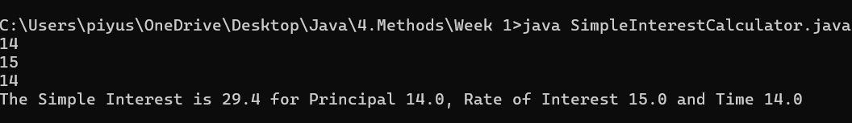

- Create a program to find the maximum number of handshakes among N number of students.
Hint =>
- Get integer input for number of students
- Use the combination = (n * (n - 1)) / 2 formula to calculate the maximum number of possible handshakes.
- Write a method to use the combination formulae to calculate the number of handshakes

Solution –
Program –
import java.util.Scanner;

public class HandshakeCalculator {
public static int calculateHandshakes(int n) {
return (n * (n - 1)) / 2;
}

public static void main(String[] args) {
Scanner sc = new Scanner(System.in);
int students = sc.nextInt();
int handshakes = calculateHandshakes(students);
System.out.println("Maximum number of handshakes: " + handshakes);
}
}
- Create a program to find the maximum number of handshakes among N number of students.
Hint =>
- Get integer input for numberOfStudents variable.
- Use the combination = (n * (n - 1)) / 2 formula to calculate the maximum number of possible handshakes.
- Display the number of possible handshakes.

Solution –
Program –
import java.util.Scanner;

public class HandshakeCalculator {
public static int calculateHandshakes(int n) {
return (n * (n - 1)) / 2;
}

public static void main(String[] args) {
Scanner sc = new Scanner(System.in);
int students = sc.nextInt();
int handshakes = calculateHandshakes(students);
System.out.println("Maximum number of handshakes: " + handshakes);
}
}
- An athlete runs in a triangular park with sides provided as input by the user in meters. If the athlete wants to complete a 5 km run, then how many rounds must the athlete complete
Hint =>
- Take user input for 3 sides of a triangle
- The perimeter of a triangle is the addition of all sides and rounds is distance/perimeter
- Write a Method to compute the number of rounds user needs to do to complete 5km run

Solution –
Program –
import java.util.Scanner;

public class TriangularParkRun {
public static double calculateRounds(double a, double b, double c) {
double perimeter = a + b + c;
return 5000 / perimeter;
}

public static void main(String[] args) {
Scanner sc = new Scanner(System.in);
double side1 = sc.nextDouble();
double side2 = sc.nextDouble();
double side3 = sc.nextDouble();
double rounds = calculateRounds(side1, side2, side3);
System.out.println("Number of rounds: " + rounds);
}
}
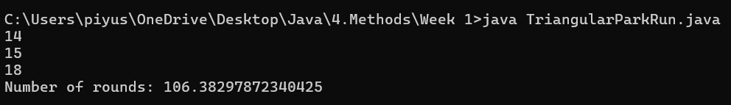
- Write a program to check whether a number is positive, negative, or zero.
Hint => Get integer input from the user. Write a Method to return -1 for negative number, 1 for positive number and 0 if number is zero

Solution –
Program –
import java.util.Scanner;

public class NumberSignChecker {
public static int checkNumber(int num) {
if (num > 0) return 1;
else if (num < 0) return -1;
else return 0;
}

public static void main(String[] args) {
Scanner sc = new Scanner(System.in);
int number = sc.nextInt();
System.out.println(checkNumber(number));
}
}

- Write a program SpringSeason that takes two int values month and day from the command line and prints “Its a Spring Season” otherwise prints “Not a Spring Season”.
Hint => Spring Season is from March 20 to June 20. Write a Method to check for Spring season and return a boolean true or false

Solution –
Program –
import java.util.Scanner;

public class SpringSeason {
public static boolean isSpring(int month, int day) {
return (month == 3 && day >= 20) || (month == 6 && day <= 20) || (month > 3 && month < 6);
}

public static void main(String[] args) {
Scanner sc = new Scanner(System.in);
int month = sc.nextInt();
int day = sc.nextInt();
System.out.println(isSpring(month, day) ? "Its a Spring Season" : "Not a Spring Season");
}
}
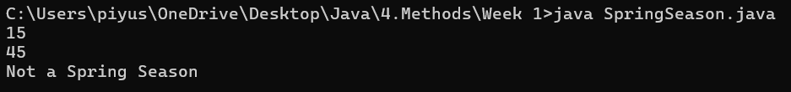

- Write a program to find the sum of n natural numbers using loop
Hint => Get integer input from the user. Write a Method to find the sum of n natural numbers using loop

Solution –
Program –
import java.util.Scanner;

public class NaturalNumberSum {
public static int findSum(int n) {
int sum = 0;
for (int i = 1; i <= n; i++) {
sum += i;
}
return sum;
}

public static void main(String[] args) {
Scanner sc = new Scanner(System.in);
int n = sc.nextInt();
System.out.println("Sum: " + findSum(n));
}
}
- Write a program to find the smallest and the largest of the 3 numbers.
Hint =>
- Take user input for 3 numbers
- Write a single method to find the smallest and largest of the three numbers
public static int[] findSmallestAndLargest(int number1, int number2, int number3)

Solution –
Program –
import java.util.Scanner;

public class MinMaxFinder {
public static int[] findSmallestAndLargest(int a, int b, int c) {
int smallest = Math.min(a, Math.min(b, c));
int largest = Math.max(a, Math.max(b, c));
return new int[]{smallest, largest};
}

public static void main(String[] args) {
Scanner sc = new Scanner(System.in);
int a = sc.nextInt();
int b = sc.nextInt();
int c = sc.nextInt();
int[] result = findSmallestAndLargest(a, b, c);
System.out.println("Smallest: " + result[0] + ", Largest: " + result[1]);
}
}
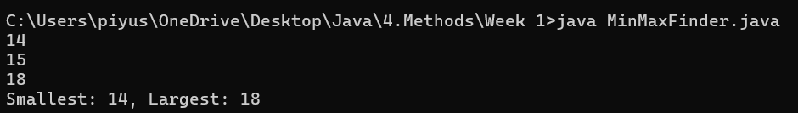
- Write a program to take 2 numbers and print their quotient and reminder
Hint =>
- Take user input as integer
- Use division operator (/) for quotient and moduli operator (%) for reminder
- Write Method to find the reminder and the quotient of a number
public static int[] findRemainderAndQuotient(int number, int divisor)

Solution –
Program –
import java.util.Scanner;

public class DivisionCalculator {
public static int[] findRemainderAndQuotient(int number, int divisor) {
return new int[]{number % divisor, number / divisor};
}

public static void main(String[] args) {
Scanner sc = new Scanner(System.in);
int number = sc.nextInt();
int divisor = sc.nextInt();
int[] result = findRemainderAndQuotient(number, divisor);
System.out.println("Remainder: " + result[0] + ", Quotient: " + result[1]);
}
}
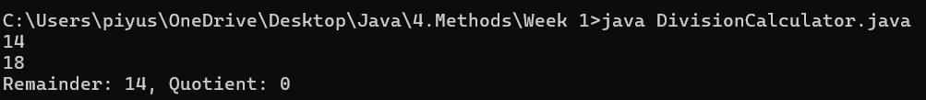
- Create a program to divide N number of chocolates among M children. Print the number of chocolates each child will get and also the remaining chocolates
Hint =>
- Get an integer value from user for the numberOfchocolates and numberOfChildren.
- Write the method to find the number of chocolates each child gets and number of remaining chocolates
public static int[] findRemainderAndQuotient(int number, int divisor)

Solution –
Program –
import java.util.Scanner;

public class ChocolateDivider {
public static int[] findRemainderAndQuotient(int number, int divisor) {
return new int[]{number % divisor, number / divisor};
}

public static void main(String[] args) {
Scanner sc = new Scanner(System.in);
int chocolates = sc.nextInt();
int children = sc.nextInt();
int[] result = findRemainderAndQuotient(chocolates, children);
System.out.println("Each child gets: " + result[1] + ", Remaining chocolates: " + result[0]);
}
}
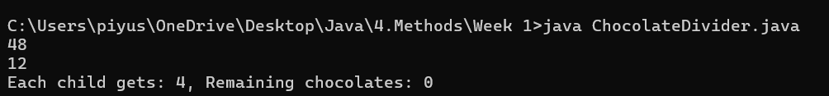
- Write a program calculate the wind chill temperature given the temperature and wind speed
Hint =>
- Write a method to calculate the wind chill temperature using the formula
$windChill = 35.74 + 0.6215 *temp + (0.4275*temp - 35.75) * windSpeed^{0.16}$
public double calculateWindChill(double temperature, double windSpeed)

Solution –
Program –
import java.util.Scanner;

public class WindChillCalculator {
public static double calculateWindChill(double temperature, double windSpeed) {
return 35.74 + 0.6215 * temperature + (0.4275 * temperature - 35.75) * Math.pow(windSpeed, 0.16);
}

public static void main(String[] args) {
Scanner sc = new Scanner(System.in);
double temperature = sc.nextDouble();
double windSpeed = sc.nextDouble();
System.out.println("Wind Chill: " + calculateWindChill(temperature, windSpeed));
}
}
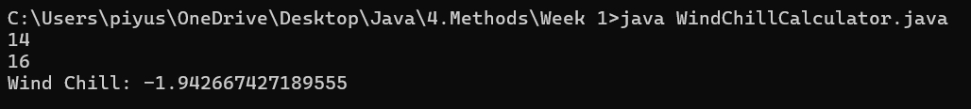
- Write a program to calculate various trigonometric functions using Math class given an angle in degrees
Hint =>
- Method to calculate various trigonometric functions, Firstly convert to radians and then use Math function to find sine, cosine and tangent.
public double[] calculateTrigonometricFunctions(double angle)

Solution –
Program –
import java.util.Scanner;

public class TrigFunctions {
public static double[] calculateTrigonometricFunctions(double angle) {
double radians = Math.toRadians(angle);
return new double[]{Math.sin(radians), Math.cos(radians), Math.tan(radians)};
}

public static void main(String[] args) {
Scanner sc = new Scanner(System.in);
double angle = sc.nextDouble();
double[] trigValues = calculateTrigonometricFunctions(angle);
System.out.println("Sin: " + trigValues[0]);
System.out.println("Cos: " + trigValues[1]);
System.out.println("Tan: " + trigValues[2]);
}
}
